BENGALI COMMUNITY (SINGAPORE) MANAGEMENT COMMITTEE 2014 - 2019
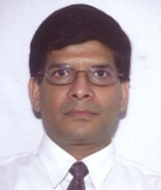
Uttom Kumar Nag
President

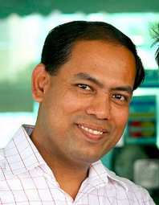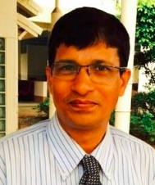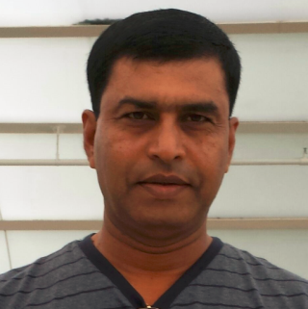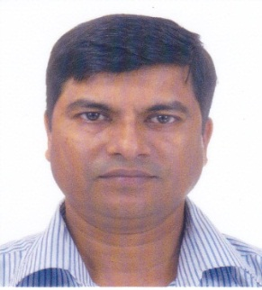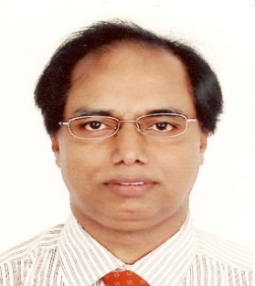
Shaibal Kumar Seal Haridash Chandra Basak Pankoj Kanti Biswas Jaharlal Sutradhar Raton Kumar
Vice President Honorary Secretary Treasurer Assistant Secretary Vice President

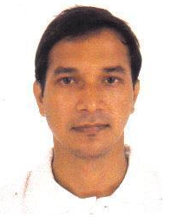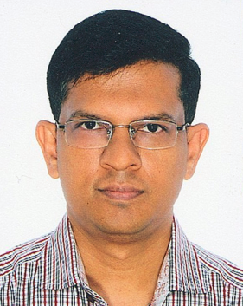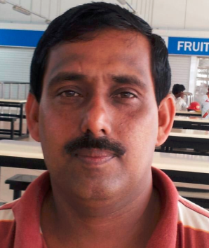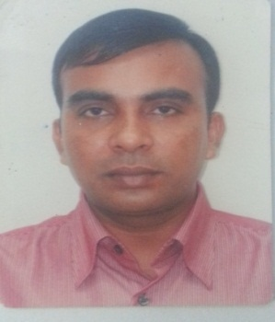
Kanu Kumar Nath Subrata Saha Kanak Bhowmik Prodip Kumar Deb Mrinal Kanti Mazumder MC Member MC Member MC Member MC Member MC Member

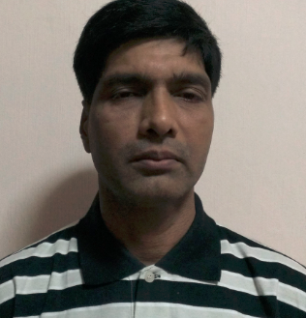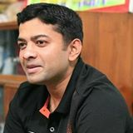
Biplab Kanti Ghosh Amitabha Nag
Auditor Auditor

